Input geometries for our mesh:

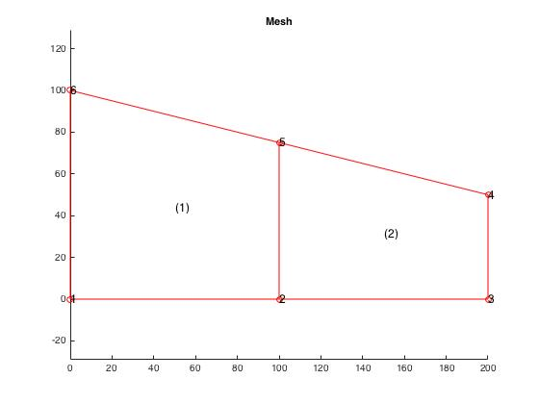

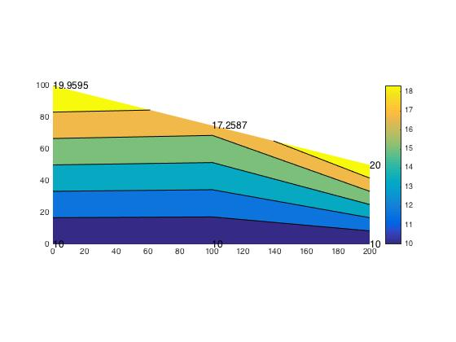

Gradients for mesh 1 and mesh 2 respectively:

Comparison between MATLAB and hand calculations for our mesh are listed below:

|  |  |  |
| --- | --- | --- |
| **-** | **MATLAB Mesh** | **Hand Calcs Mesh** |
| Θ5 | 17.2587 | 17.5589 |
| Θ6 | 19.9595 | 20.8934 |

For point A our values are:

|  |  |  |
| --- | --- | --- |
| **-** | **MATLAB Grad value** | **Hand Calc’ed value** |
| ΘA | ~16 | 15.8863 |

Discussion:

Similar to problem set 7, an interesting part of the solution is that node 5 has a slightly lower temperature even though it is exposed directly to the external q that is applied. There is a prescribed temperature at 4 and approximately the same value is attained at node 6.